Dashboard Design

Date | 25 July 2026
Team ID | Lisha Chaudhary
Project Name | Food Ordering Behaviour
Maximum Marks | 5 Marks

Activity 1: Interactive and Visually Appealing Dashboards
The dashboard was designed using Tableau to provide an interactive and user-friendly visualization of food delivery performance. It combines KPI cards, bar charts, pie charts, treemaps, heatmaps, packed bubble charts, and line charts into a single dashboard, allowing users to monitor operational performance, customer behavior, and revenue trends. Interactive filters enable users to explore insights by cuisine, city, meal type, weather conditions, restaurant type, and customer demographics, making the dashboard suitable for quick business decision-making.
Major Outcomes & Key Insights from the Dashboard
- High-Volume Operational Scale: The dashboard tracks an aggregate of 50,000 total orders, generating a total order value of ₹27.39M and delivery fee revenue of ₹29,82,136. This large dataset supports statistically reliable performance benchmarking across cuisines, cities, and meal times.
- Balanced Cuisine Revenue Contribution: The ‘Revenue Contribution by Cuisine’ bar chart shows a tightly balanced spread — Desserts (₹46.27L), Fast Food (₹45.93L), South Indian (₹45.83L), Chinese (₹45.81L), Biryani (₹45.36L), and North Indian (₹44.67L) — with less than a 4% gap between the highest and lowest performing cuisine, indicating no single cuisine dominates the platform’s revenue mix.
- Even Meal-Time Revenue Distribution: The ‘Revenue Generated from Each Meal’ pie chart shows Breakfast (25.29%), Snacks (25.05%), Lunch (25.03%), and Dinner (24.63%) contributing almost identical shares of revenue, suggesting consistent ordering behavior throughout the day rather than concentration around a single peak meal window.
- Consistent Spend Across Order Occasions: The ‘Company vs Total Order Value’ donut chart (total ₹2,73,86,555) shows near-equal contribution from Partner (₹69,87,173), Friends (₹68,92,991), Alone (₹68,52,346), and Family (₹66,54,045) orders — indicating solo ordering is just as significant a behavior as group ordering.
- Stable Delivery Performance Across Cities: The ‘Time Taken to Order by Different City’ line chart shows average times clustered tightly between 7.42 and 7.55 units across Bangalore, Chandigarh, Delhi, Hyderabad, Mumbai, and Pune — reflecting consistent logistical execution regardless of region.
- Millennial-Led, Cross-Generational Revenue: The ‘Age Group-Wise Revenue Distribution’ bubble chart shows Millennials as the largest revenue contributor, followed by Adults, Gen Z, and Children — showing the platform’s core demand comes from working-age adults while still maintaining broader generational reach.
- City-Specific Weather Sensitivity: The ‘Impact of Weather on Order Value Across Cities’ heatmap shows that rain affects order value differently by city rather than following one uniform pattern — some cities see higher order values on rainy days, others lower — suggesting weather-driven demand shifts should be modeled per city rather than platform-wide.
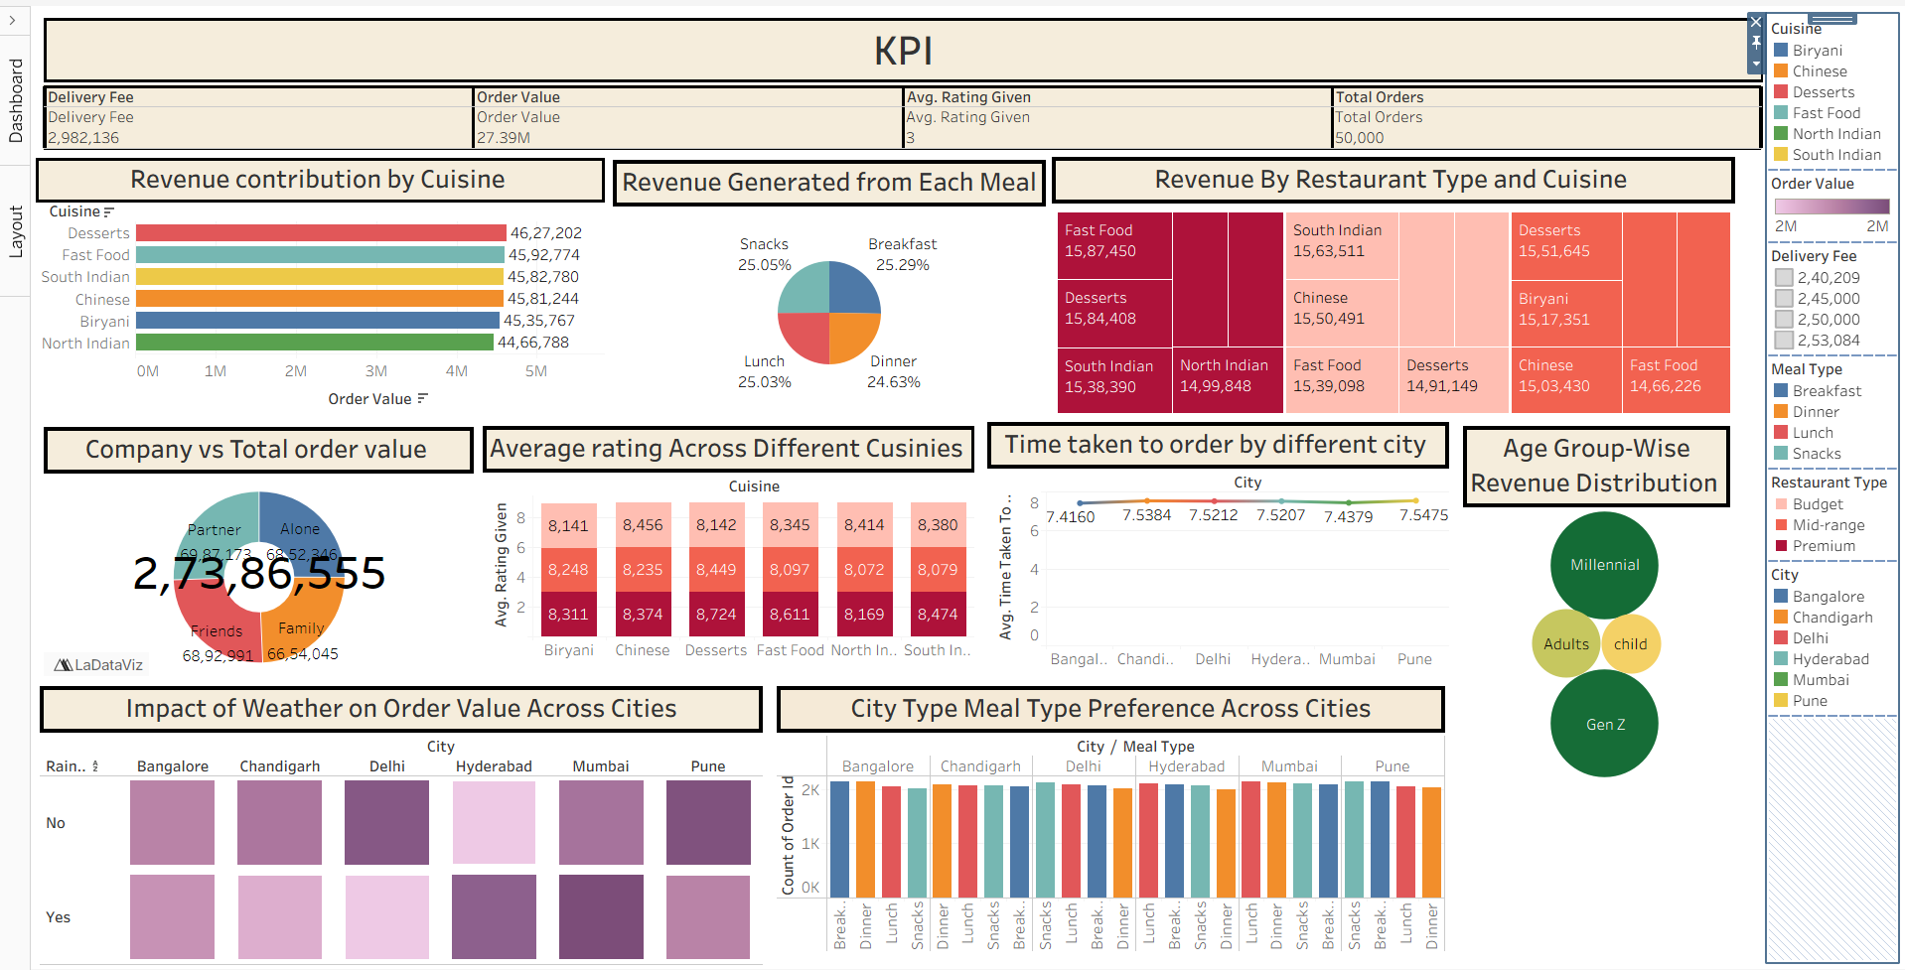
Activity 2: Live Deployment Link
Below is the verified public access link to the interactive, cloud-hosted visualization story:
Tableau Public Dashboard Link:
https://public.tableau.com/views/Dashboard-FoodOrderingBehaviour/Dashboard2?:language=en-US&:sid=&:redirect=auth&:display_count=n&:origin=viz_share_link

